**Interoffice Memorandum**

**DATE:** June 2nd, 2020

**TO:** Jason Wolting, Supervisor & Coordinator, Waste Reduction, Facilities Management

**FROM:** Joel Cohen, Gareth Marriott, Ryan Woodward

**SUBJECT:** Campus wide soft plastic recycling

This proposal provides a plan to implement campus-wide soft plastics recycling across the University of Victoria in an attempt to lower Uvic’s plastic landfill waste.

While the University of Victoria has made considerable efforts to reduce it’s campus’ landfill waste, the only option available to students and faculty is a single “Expanded Recycling Station” located in the Student Union Building. Having only one location on campus for disposing of soft plastics in an eco-friendly way makes it unlikely for students to use it. It’s suspected that most students aren’t even aware that such a station exists. Uvic already has 40 recycling kiosks[1] across campus. Adding soft plastic recycling to some or all of these kiosks could be an effective way to reduce Uvic’s plastic waste.

### **Problem Description**

1.1 Need Statement

University of Victoria’s 2020/21 sustainability action plan intends to increase the landfill waste diversion rate to 82%.[2] The sort-it-out stations installed in 2019 do not have a compartment to recycle clean soft plastics nor clean styrofoam; These stations do not have information about University of Victoria’s office soft plastics recycling program listed. The stations recommend placing these items in the landfill waste bin. This means that 100% of the sort-it-out stations will fail to divert soft plastics and styrofoam from the landfill.

1.2 Goal Statement

The goal is to determine the feasibility of introducing a soft plastics recycling option at each of the sort-it-out stations

1.3 Objectives

The proposed actions will

* Help meet the waste diversion rate of 82%
* Help achieve UVIC’s ultimate zero waste goal
* Educate the community about soft plastics recycling

1.4 Constraints

* A 5 year payback period
* A maximum spending limit of $100,000

### **Plan of Action**

This section isolates the key problems in implementing campus-wide soft plastic recycling.

2.1 How much will it cost to add each bin to the sort-it-out stations, and what is the cost of adding lids to garbage bins with a picture showing what doesn’t go in?

Research wholesale costs and whether UVIC facilities have extra bins.

2.2 What style of bin should be introduced?

Coordinate with facilities to determine whether transportation methods of existing bins require a specific type of bin, or see if there is a possibility of using general bins with different lids?

2.3 What if the soft plastics bin is compromised by contaminated plastics?

Contact facilities to determine procedures for cleaning current recycling bins and determine if new cleaning procedures are required.

2.4 How are the bins going to be cleaned? How much money will need to be spent on cleaning? How will the plastics be cleaned?

Investigate the time and labour cost associated with adding additional bins.

2.5 Are the plastics going to be cleaned/processed before being transported to a recycling facility?

Investigate the need for prewashing soft plastic and on-campus solutions.

2.6 Can soft plastics be cleaned in a way to reduce microplastic contamination? Would wastewater decontamination solutions need to be introduced?

Contact wastewater experts and BC hydro to determine acceptable levels of microplastic contamination and examine on-site treatment solutions if necessary.

2.7 What is the current capacity of the UVIC recycling plant to accept soft plastics? How and when are the soft plastics being transported to a different facility? How often? Where? And at what cost?

Contact facilities to determine the extent of soft plastic recycling, and speak with Jason Wolting, Waste Reduction supervisor.

### **Timeline**

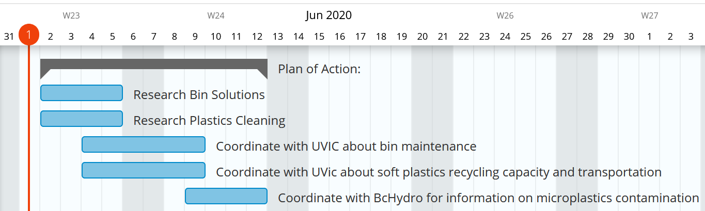

### **Budget**

See table 2 for the cost of research for the proposed project.

**Table 2: proposed budget for project study**

|  |  |  |
| --- | --- | --- |
| **Item** | **Amount** | **Cost** |
| Research bin solutions | 4 hours / $18 per hour | 72 |
| Research plastics cleaning | 4 hours / $18 per hour | 72 |
| Coordinate with Uvic for information on bin maintenance | 6 hours / $18 per hour | 108 |
| Coordinate with Uvic about soft plastics recycling capacity and transportation | 6 hours / $18 per hour | 108 |
| Coordinate with BcHydro for information on microplastics contamination | 4 hours / $18 per hour | 72 |
| **Total** | | 432 |

### **Credentials**

As computer science students we bring a unique perspective to the issues of recycling. Our background gives a unique opportunity to incorporate a variety of technical solutions to the logistical problem of plastic recycling. Our group has a wide variety of experiences from previous work in management roles to extensive research and formal report writing. This combination of organization, management, and report writing will propel our group towards the completion of a comprehensive study on recycling at UVIC.

### **Conclusion**

The University of Victoria prides itself on its environmental goals and action. To help meet Uvic’s goal to build upon its environmental waste diversion of 82%[3], our team will research the logistics of implementing campus-wide soft plastic recycling. The research will include the cost of bins and maintenance, the feasibility of plastics cleaning, recycling capacity and transportation, and the possibility of microplastic contamination. The research will be completed by June 12th and cost $432. The study offers great potential in increasing Uvic’s waste diversion efforts by adding soft plastics as a recycling option to campus-wide recycling services.

1. “Recycling and composting stations on campus,” University of Victoria. [Online]. Available: https://www.uvic.ca/sustainability/assets/docs/FMGT_02673_RecyclingTentCardUpdate_map_webOUTrev.pdf
2. “SUSTAINABILITY ACTION PLAN,” University of Victoria. [Online]. Available: https://www.uvic.ca/sustainability/assets/docs/uvic-sustainability-action-plan-2020-2021.pdf.
3. “SUSTAINABILITY ACTION PLAN,” University of Victoria. [Online]. Available: https://www.uvic.ca/sustainability/assets/docs/uvic-sustainability-action-plan-2020-2021.pdf.